**MODULE 2: THE SCIENCE OF BREATHING**

**LESSON 7: ENERGY MANAGEMENT AND THE ROLE OF BREATHWORK**

The mechanism of our neurobiological system is innately designed to provide us with high energy in times of high demand and then to restore itself so that restoration, recovery, growth and rejuvenation can occur in times of rest. As human beings however, given the complex nature of our mind-body-consciousness system, being in this “mode” gives us the opportunity to create, innovate and grow.

To get a clearer understanding of what is meant by this, let’s look at what happens to the body and brain when the stress response kicks in:

**The Fight-Flight Reaction (Sympathetic Nervous System)**

We respond to stress via two pathways, the neurological response and the chemical response

1. **The Neurological response: The Fast Track**

* the autonomic nervous system (ANS) turns on in response to something real or imagined in the environment
* The ANS passes along information directly through the spinal cord and spinal nerves that are connected to the adrenal glands that sit on top of the kidneys
* Once this lightning bolt of information reaches the adrenal glands, they push out a surge of adrenaline that goes directly into the bloodstream to mobilise resources for action

The effect is:

* increased heart rate and blood pressure
* reduced flow to digestive organs (thus the dry mouth and feeling of butterflies which is blood being shunted away from the intestines)
* increased blood flow to the extremities for action
* glucose is mobilised in the bloodstream for energy
* brain becomes super aware
* pupils are dilated, and lenses cleared to facilitate seeing greater distances
* airways dilate allowing greater oxygen transfer in the lungs

**2. The Chemical response: The Slow Track**

Like the neurological response, the chemical response can be triggered by a reaction to something outside of ourselves or an internal thought:

* the neural signal is sent to the part of the midbrain called the hypothalamus
* a chemical peptide called Corticotrophin releasing hormone (CRH) is released, sending a message to the pituitary gland in the brain
* the pituitary gland makes another chemical peptide called Adrenocorticotrophic hormone (ACTH) and sends it to the adrenal glands
* The adrenal glands in turn release cortisol which effects certain biological reactions

**Recovery Mode**

This acute stress response creates a tremendous surge of energy that is meant be used to act. However, once the action has been taken and the threat has been dealt with, the system returns to its resting state, the parasympathetic response, the rest and digest mode:

* where the body’s responses are slowed down
* heart rate and BP decreases
* respiratory rate slows down
* blood flow to the digestive system increases

Unlike animals, humans perceive a whole host of other experiences as stressors. In fact, everyday life experiences, the act of multitasking and the constant contact with technology triggers the stress response. We also turn on the stress response without the actual stressor being present.

As a result, we get locked into a state of chronic stress. The body is not designed for long term stress so when the stress response is chronically activated, we are headed for burnout and disease.

**Energy Zone Map**

The following map illustrates the physical and behavioural symptoms that we experience as we move from a state of living in accordance with the energy laws (Optimum Zone) to Danger Zone and eventually to Burnout Zone

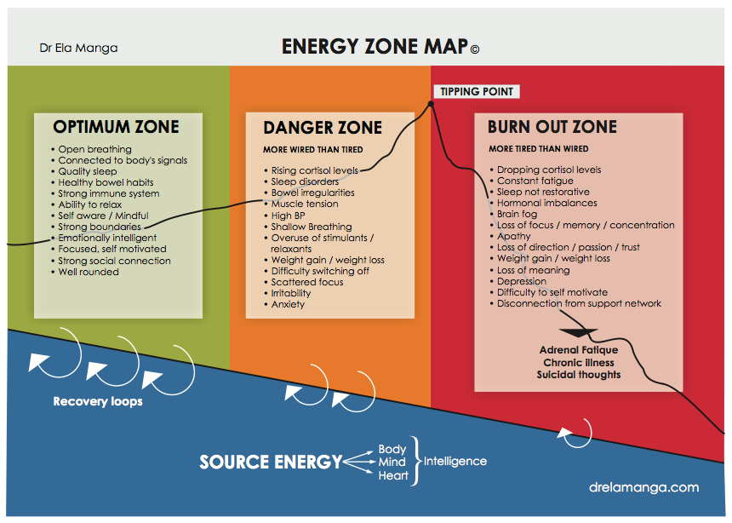

**Optimum Zone**

Living in this zone means that we are living in perfect harmony with our inner rhythms and cycles, and the rhythms of nature. We are mindful, conscious and self-aware. We fully tap into our three sources of natural energy. We support the physical body with healthy nourishing food, we exercise intelligently, are well hydrated, sleep well and use the stress response wisely. We are open hearted and live by responding rather than reacting to situations. We are energised by living in the present moment.

Physiologically, in this ideal state, we might experience bouts of stress, but the system would return to a state of homeostasis. Cortisol would be released according to its natural circadian rhythm i.e. high in the morning and low in the evenings.

In balance, we have adequate amounts of serotonin in the gut to promote the production of melatonin at night. When we can fall asleep at night easily and feel rested, and have good energy throughout the day, we are in good balance.

We experience ‘authentic energy’, meaning, purpose and inspiration when we:

- use adrenalised energy wisely and replenish our energy resources through recovery loops.

* tap into source energy through StillPoint moments.
* tend to all Body Intelligence (sleep, regular meals, healthy movement), Mind Intelligence (mindfulness) and Heart Intelligence (connection with self and others)
* move and express our energy through the three channels

**Danger Zone – More Wired than Tired**

As the circulating levels of the stress hormones adrenaline and cortisol start to rise, we begin to experience the physical and behavioural effects.

**Cardiac effects**

High circulating levels of adrenaline cause a high heart rate, increases tone of arteries leading to hypertension

**Gastro Intestinal Tract (GIT) effects**

Blood is being constantly shunted away from the digestive system. This impacts the way food is digested, and nutrients absorbed which leads to a whole host of digestive disorders, bloating, constipation, irritable bowel syndrome (IBS) symptoms

**Muscle tension and headaches**

* in chronic stress mode, the muscle tone increases causing chronic tension in the neck and shoulders
* tension headaches
* poor posture impacts on breathing which feeds stress response.

**Neurological effects**

When we are in chronic stress mode, most of the blood flow to the brain is diverted to the reptilian brain and midbrain and away from the forebrain, which is our higher cognitive centre. As a result, we become more reactive and anxious which further exacerbates the stress response. It also causes degeneration of the cells in the hippocampus which is responsible to form new memories and acquire new knowledge.

**Glucose levels**

Cortisol mobilises the release of stored glucose (gluconeogenesis) into the bloodstream. The effect is glucose spikes into the bloodstream, which in turn raises insulin levels, triggering further sugar cravings and the cycle continues which creates a predisposition to insulin resistance and development of fat deposits around the belly.

**Thyroid function and metabolism**

High cortisol levels desensitise the thyroid hormone which slows down metabolism, causes fatigue and weight gain.

**Immune system effects**

Cortisol is an immune system suppressant and anti-inflammatory, so if levels are chronically raised, the immune system gets suppressed causing an increased susceptibility to infections. Cortisol is also a potent anti-inflammatory.

**Burnout Zone – More Tired than Wired**

In this phase, the adrenal glands are unable to keep up with the body’s demands for stress hormones and the stress hormone levels begin to drop. Energy levels begin to drop, and symptoms may include lethargy, depression, lack of motivation, apathy, constant fatigue. Physically, health conditions are more chronic as the imbalances become more driven into the cells paving the way for chronic illness and full on adrenal fatigue. Common conditions we see with people in this zone: Fibromyalgia, auto immune conditions, diabetes, cancer.

**NOTE**:

When explaining the energy zone map, the following needs to be noted:

* The energy zone map is a tool of awareness which illustrates the general flow of energy in people with chronic stress
* Some people may be mentally resilient (in phase 1) but physically in phase 2.
* Therefore, the gauge and the map create an awareness of what dimension or sources of energy requires more attention and support.

**Recovery Loops**

The key to staying in the high-performance zone and managing our energy is the ability to consciously break the stress cycle and activate *recovery loops****,*** so that the body is able to restore, replenish and recover.

**The most powerful and effective recovery loop is the breath, the bridge between mind, body and soul.**

Our breath is the most exquisite example of innate wisdom in action. It quietly sustains our life force while we get on with the business of our lives. Most of us have never even considered the gift and value of the breath until something comes in the way of its flow.

Our breath moves, flows and adapts itself under the radar of our conscious awareness and yet, when we come alive to it, notice it and harness it, it becomes the very force that shifts us from operating at baseline level to expanding and growing in ways we never imagined possible.

The breathing cycle, the inhale and the exhale, is the perfect expression of the Law of Cycles. With every inhalation, high energy stress response is balanced by the exhalation and relaxation state. This can even be measured in our heart rate. When we inhale, the heart rate increases slightly, and as we exhale it decreases slightly. This elasticity of our heart rate is known as *heart rate variability.*

Authentic energy is reflected in the heart rate variability. In other words, the more balanced the breathing pattern, the higher the heart rate variability, the more robust our energy system and the less prone we are to the symptoms of adrenalised energy.

If we are stuck in danger zone or burnout zone, the breath will reflect that with a habitual pattern of breathing that is shallow, fast and restricted. In addition, our breathing pattern, posture and tone of voice is constantly sending feedback signals back to the brain. If the body is sending stress signals to the brain through a shallow breath and tight muscles, the brain will react accordingly by feeding adrenalised energy. Eventually, over time, adrenalised energy becomes a habit and an addiction.

While our breathing is part of this autonomic nervous system (automated energy management system), it is the only function that we can consciously override. In just one breath, we can break the cycle of toxic adrenalised energy and shift our energy state.

If that can happen with just one breath, imagine what we are able to achieve if we bring conscious breathing into our daily awareness and integrate it into our lifestyle.