MODULE 6: ENERGY ANATOMY

LESSON 2: THE FIVE SHEATHS OF ENERGY

“Energy is Consciousness Made Visible”

In this lesson we explore how Universal energy gets embodied in five interconnected sheaths of energy that make us who we are. In the ancient Vedic traditions these sheaths are also known as “Koshas”. By understanding these sheaths, we have a greater sense of how breathwork effects change and also which aspect of ourselves we are experiencing in various stages of a session.
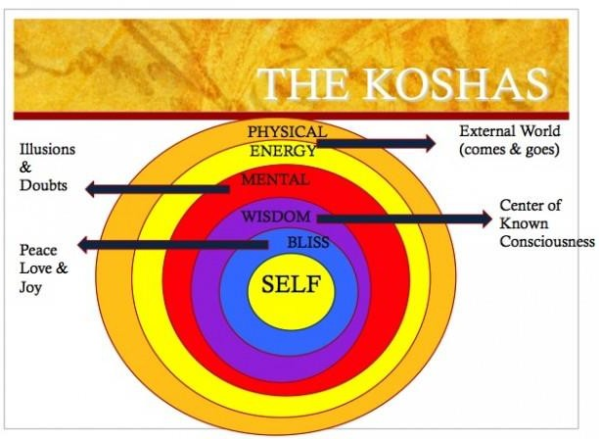

The Physical Body
The physical body is the densest of these 5 layers of energy.

The Energy Body
This is the sheath that is closest to the physical body and that weaves through it through the chakras. This layer is not visible but can be experienced as sensations. It is through this sheath that Universal Life force interfaces with the physical body.
So much of our communication with the world happens on an energetic level. Consider the way we feel when you're in a room with an angry person or the peace you feel when you are walking in nature.

When the prana body is strengthened, it can be visible to the naked eyes as a glow or aura. It is often what is depicted as a halo or aura around saints and mystics. In breathwork when we begin to feel tingling, waves of energy, heat or cold we are having a tangible experience of the energy body. Breathing allows easy access to the other sheaths through this layer.

The Mental Body
This is the sheath of energy that is made of thought processes. It is the part of us that creates meaning out of the world we inhabit. But just as the physical body has layers of skin, fat, blood, and bones, so the mental body has its own layers. The most superficial layer comprises passing thoughts, images, perceptions and emotions. Some of these thoughts are like bubbles in the ocean, that rise and disappear while others are like tides and have a stronger hold and more influence. The deeper levels of this sheath contain the powerful mental structures formed by the beliefs and conditioning that you've absorbed from your family and culture as well as from your accumulated mental patterns. These deep thought grooves in the mental body cause your perceptions of yourself and your life to run in certain fixed patterns (see module 5).

The Wisdom or Awareness Body
This is the energy of the higher mind operating as discriminating intelligence, insight and intuition and creativity. Artists often describe this state as “being in the flow”. We are accessing this sheath when we become completely immersed in a project like writing or painting or even problem solving. We often have moments of being in this state in a breathwork session when we have a deep insight, vision or sense of knowingness.

The Bliss/ Causal body
This body is the interface between universal and individual consciousness. It is a space of stillness and contentment. Here, there is no fear. It is the energy of pure unconditional love, gratitude and open heartedness.

Contact with the bliss body develops through practice, especially practices that teach the mind to let go of the thoughts that hide the bliss body. When you are in touch with your bliss body, you know that your nature is joyful and free. You are in the bliss body in those moments during which you recognize - viscerally rather than intellectually - that love is the deepest reality, beyond mental constructs or ideas. In fact, the greatest gift of breathwork is its power to awaken us to our body of bliss.

It is possible to be conscious of yourself in all these layers and levels. To be aware and present in all these sheaths is to awaken to your own life and to integrate all the parts of yourself. It then becomes natural to sense the universal Self that expresses itself as our individual Self.

Exercise: Meditations on the Koshas:

Physical Body:
To get into the physical body, try this exercise. Notice your feet in your shoes. Tighten and relax the muscles in your calves. Touch your face and sense the contact between the fingers and the skin. Put your hand over your chest and feel your heartbeat or feel the contact between the hand and the flesh. Then pick an inner organ - your liver, heart, or kidneys - and try to find it with your attention. Really sink your attention into that organ. Just as you would in meditation, notice when you become distracted by thoughts. When this happens, note "thought" to yourself and come back to sensing the organ. Notice the settling and grounding effect of this practice.

Energy Body:
One way to tune into the power within the energy body is to practice letting yourself "be breathed." Without changing your breathing pattern, become aware of the breath flowing into and out of your body as a natural, spontaneous flow.
Instead of feeling "I am breathing," feel "I'm being breathed." Let yourself relax into this feeling. If you notice your breath tightening, just notice it, with the thought "I am being breathed." Eventually you may begin to feel the breath as energy, and you may sense that the body is bigger than the boundaries of the skin. This is a sign that you've entered the vital energy body. As this happens, you may find that your posture automatically readjusts itself, that your back or hips open. These are all effects of consciously accessing the vital energy body, which is the storehouse of healing power in your system.

Mental Body:
Try this basic self-inquiry, adapted from an exercise developed by the spiritual teacher Byron Katie. Look at a situation in your life that is charged in some way. Write down your thoughts about it. Then, one by one, consider each thought and ask yourself, "What would I be without this thought?" Notice how your breathing, your energy, and your mental experience shift.
Consciously replace the thought with one that feels empowering and real - such as "I am free to choose my attitudes" or "There is another way to see this." Notice whether this new thought brings greater spaciousness to your mind.

Wisdom Body:
Right now, notice that something in you observes that you are reading. That same observing "I" is also aware of your thoughts, your mood, the way your body feels, your energy level. It knows all this without being involved in it. As you embody awareness, notice if you can contain all the other levels of experience - without getting attached to their meaning or outcome.

Bliss Body:
Ask yourself, "Where is bliss?" Ask in an open-ended way and tune in to the subtle feelings of tenderness, joy, and contentment that can show up at the most unexpected of moments. Let yourself open to the possibility that bliss is your true nature. Don't worry if there is no immediate answer or response. The bliss body may take time to reveal itself, but often happens at the end of a breathwork session when the heart opens. When the bliss body does reveal itself, it can seem miraculous, like a gift, and yet completely natural.
Your essence is innately blissful. But you may need to learn how to turn deep inside to recognize it.

